**A Flexible Encoding Framework and Autonomic Runtime System for Progressive Streaming of Scientific Data**

Year 1 report

Duong Hoang, Aashish Panta, Giorgio Scorzelli, Daniel Balouek-Thomert, Philip Davis**,**Manish Parashar (co-PI) and Valerio Pascucci (PI)

Scientific Computing and Imaging Institute (SCI), University of Utah

During the first year of the project, we developed and tested some of the foundational components needed to establish a novel data reduction framework that allows efficient storing, transferring, and working with only the most relevant bits of data in the form of compressed approximations in both resolution and precision while being aware of the underlying heterogeneous system architecture of the computing facility and associated space-time constraints. Our main target has been the use of the NASA GEOS DYAMOND dataset, which is about 4PB in total storage and is actively explored and analyzed by climate scientists at NASA (see Figure 1).

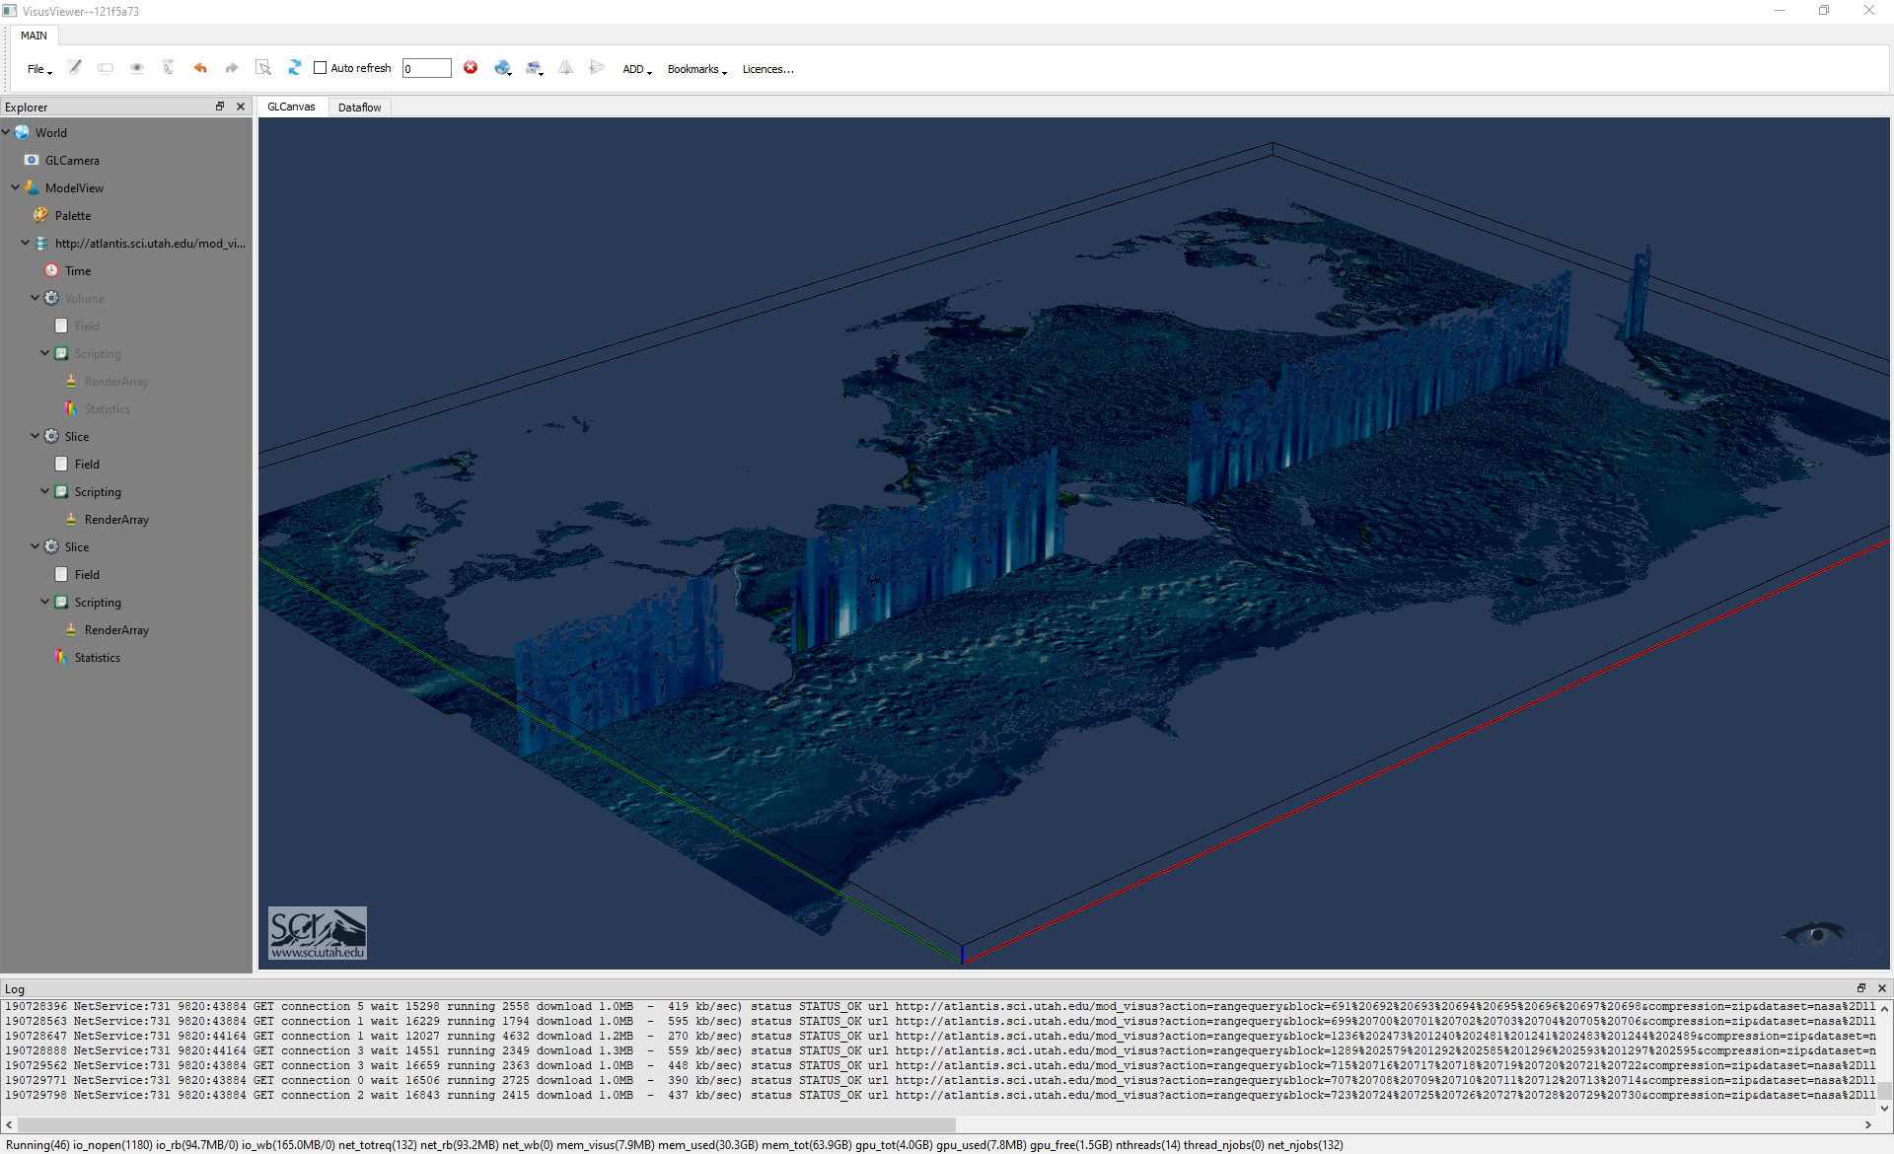**Figure 1** - Interactive 3D visualization of one time step of LLC4320 (dimensions 17280 x 12960 x 90). Here we show a horizontal slice and a vertical slice.

The framework we are building is designed to advance the field of scientific data reduction in two main research areas:

* Development of a novel data model for storing and working with compressed scalar and vector fields that allows progressive decoding of data chunks to form approximations at any desired combination of resolution and precision, all from a single compressed data layout. Our data model will simultaneously achieve high compression ratios, efficient progressive streaming, and data access in both accuracy and resolution, as well as the capability to work efficiently with compressed data without explicit decompression.
* Development of a novel runtime system that automates data reduction and resource allocation decisions for in-situ workflows, adaptively satisfying a range of user, application, and system constraints. Our runtime system will dynamically decide how to couple reduction tasks with both data producers and data consumers, ranging from performing reduction in-process to achieving reduction on dedicated staging nodes, to a hybrid combination.

Our goal is to produce a setup where scientists can explore the data with minimal use of computing and human resources. For example, the current practice is for a scientist to ask a staff member to create a particular animation (e.g., for a vertical slice over time) and wait for the video to be created so that it can be played to understand a specific feature in the data. A new exploration will require making another such request and repeating this offline process. In our approach, we would provide the climate scientist with a user interface that allows directly to select what data to be examined and play it over time immediately without needing additional support. To this end, we have developed a novel data encoding for large-scale climate simulation data that allows:

* Reencode the entire data (or any portion of it) in a novel format that is more space-efficient and allows direct access to the required information without unnecessary data movement overhead. For example, extracting a slice in any direction would be achieved directly without loading an entire volume only to discard the data not needed. The efficiency of this novel data layout also achieves, on average (more testing is required), a reduction in storage requirement by a factor of 3x with virtually no loss in accuracy. In particular, the data is not bitwise identical in the same way the coordinates of a point on the plane would be different if one were to convert from cartesian coordinates to polar coordinates when using floating point number representation pm a computer.
* We also introduce data compression to reduce data movements during analysis. For example, we can achieve a factor of about 1000x in data reduction when visualizing the data with no loss in visual quality.
* Interactive exploration and visualization of multi-terabyte (to be scaled to multi-petabyte) -size data using Python-based Jupyter notebooks on a desktop or laptop computer.
* Fine-grained modulation of spatial resolution and/or numerical precision in the data to tailor the data movement to the analysis task at hand.
* Remote progressive data streaming from a server to a desktop client, with local caching in the background, to speed up future queries.

The main activities of the first year include the following:

* Improved the decoding capability of our system in three ways:
  + Made the API more flexible: instead of allowing the user to query along a single sequence of increasing resolution levels, we allow arbitrary combinations of subsampling along all three axes: X/Y/Z (or X/Y/Time). This allows the domain scientists to tailor the amount of data transferred to the analysis task at hand and not move more data than is strictly needed while preserving the quality at least at the level required by the user. For example, for animating time series, one can subsample X and Y more than time; likewise, for vertical slicing, X and Y may be subsampled more than the depth.
  + Developed a Python API to allow users to easily query data from our encoding without going through the lower-level C++ interface, which domain scientists would find hard to use.
  + Developed a high-level C++ API to allow users to access the various encoded 3D volumes as a single dataset, with dimensions X/Y/Face/Depth/Time. The high-level C++ API enables users to make arbitrary queries that get decomposed, rearranged, and parallelized by a query processing engine before the queries are forwarded to the low-level C++ API that performs data I/O and decoding. This high-level C++ API is being tested and integrated into the NASA Ames Research Center visualization team’s own codebase.

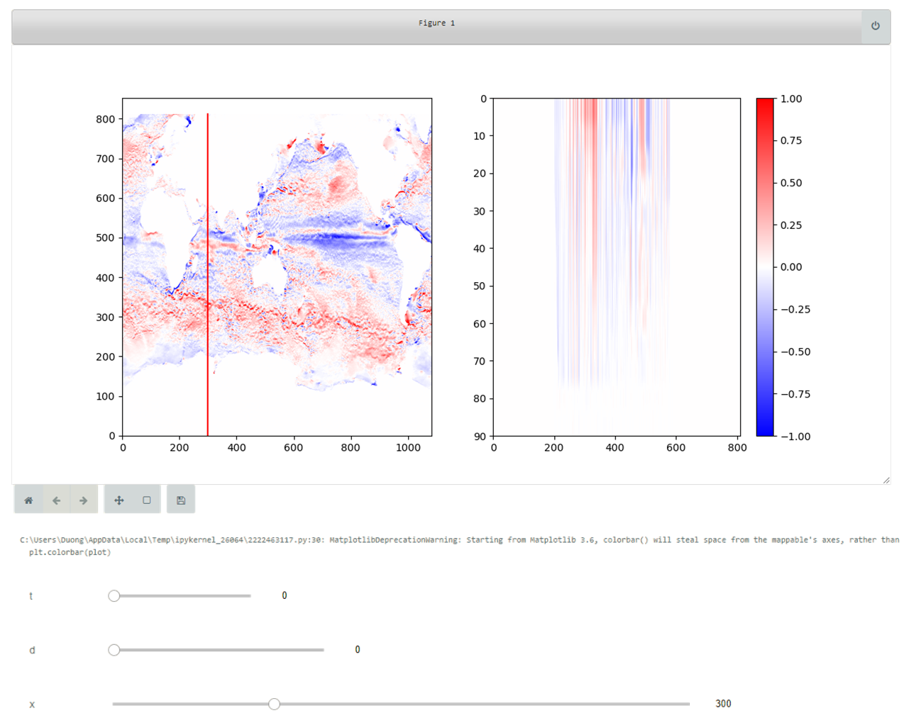  
**Figure 2 -** Interactive vertical slicing of LLC2160 data in a Jupyter notebook.

* On Pleiades:
  + Set up a data conversion pipeline to streamline the process of data conversion from “raw” format to our own encoding
    - The conversion speed is 1 TB/hour using 16 cores, with expected perfect scaling: with 16000 cores, the expected speed rate is 1 PB/hour, depending on the performance of the I/O system.
  + Encoded 100 TB (out of 4 PB total) of the DYAMOND MITgcm 2160 lat-lon-cap simulation of the ocean in our data format and:
  + Reencodeed this 100TB piece of data in the new progressive encoding scheme gaining already in storage efficiency by going down to 37 TB with virtually no loss in accuracy.
  + Created Jupyter notebooks demonstrating the various capabilities of the system that can be run from any machine with SSH connection to PFE.
  + Shared the notebooks with domain scientists, who can:
    - Interactively visualize horizontal slices: domain experts interactively explore cross-sections of DYAMOND data at different heights/depths over time
    - On the fly animate the time series at fine temporal granularity: domain experts can navigate to a time step of choice and play the time series which animates the field through all time steps starting at the current time step.
    - Interactively slice the data vertically through all 90 depths — domain experts indicate the location of the vertical cross-section, the system immediately visualizes the slice at the indicated location; the slice itself can also be animated through time on-the-fly. See Figure 2.
    - Interactively query a region-of-interest (ROI) — domain experts interactively navigates to a spatial region of interest via panning; the ROI is shown at full resolution, and precision can be animated through time on-the-fly. See Figure 3.
    - Instantly plot derived statistical quantities: domain experts select a region of interest, and the system plots the rolling mean of this region through the entire time series. See Figure 4.
    - Interactively modulate data quality by increasing the resolution and/or precision as needed: domain experts can move sliders to request more data, either by increasing data resolution or data precision until data quality is satisfactory. The queried data can then either be visualized, used for further analysis, or saved to disk to be used later.

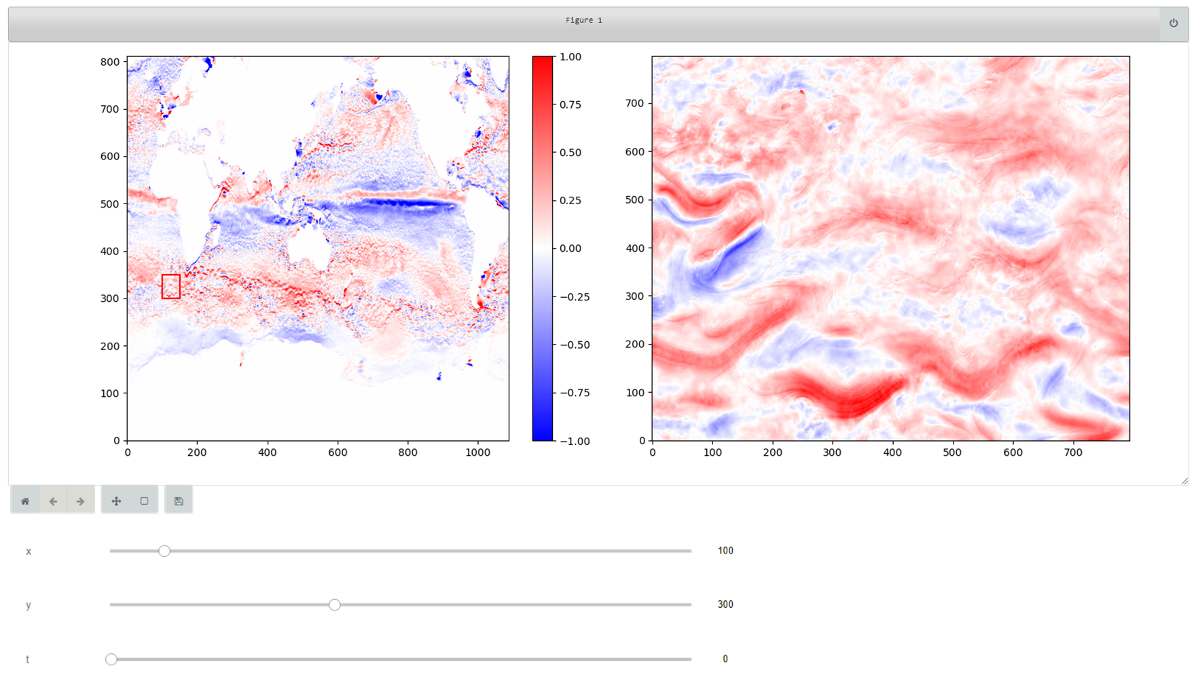

**Figure 3 -** Visualizing a region of interest at high precision and high resolution in a Jupyter notebook.

* Conducted extensive experiments to evaluate data quality at various resolution and precision levels (see Figure 5) and showed that:
  + A data reduction of 600x (200 TB becomes 300 GB) is possible with no loss of data quality by visualization. See Figure 7.
  + A data reduction of 10000x (200 TB becomes 20 GB) is possible with minimal loss of data quality by visualization. See Figure 8.

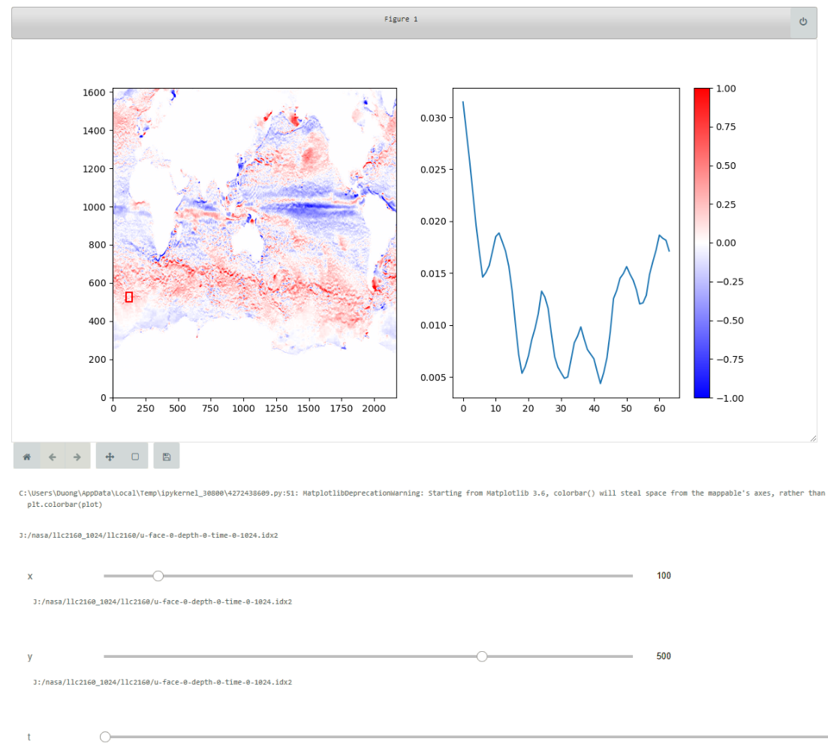

**Figure 4 -** Interactive plotting of a derived quantity (rolling window of mean velocity) through time in a Jupyter notebook.

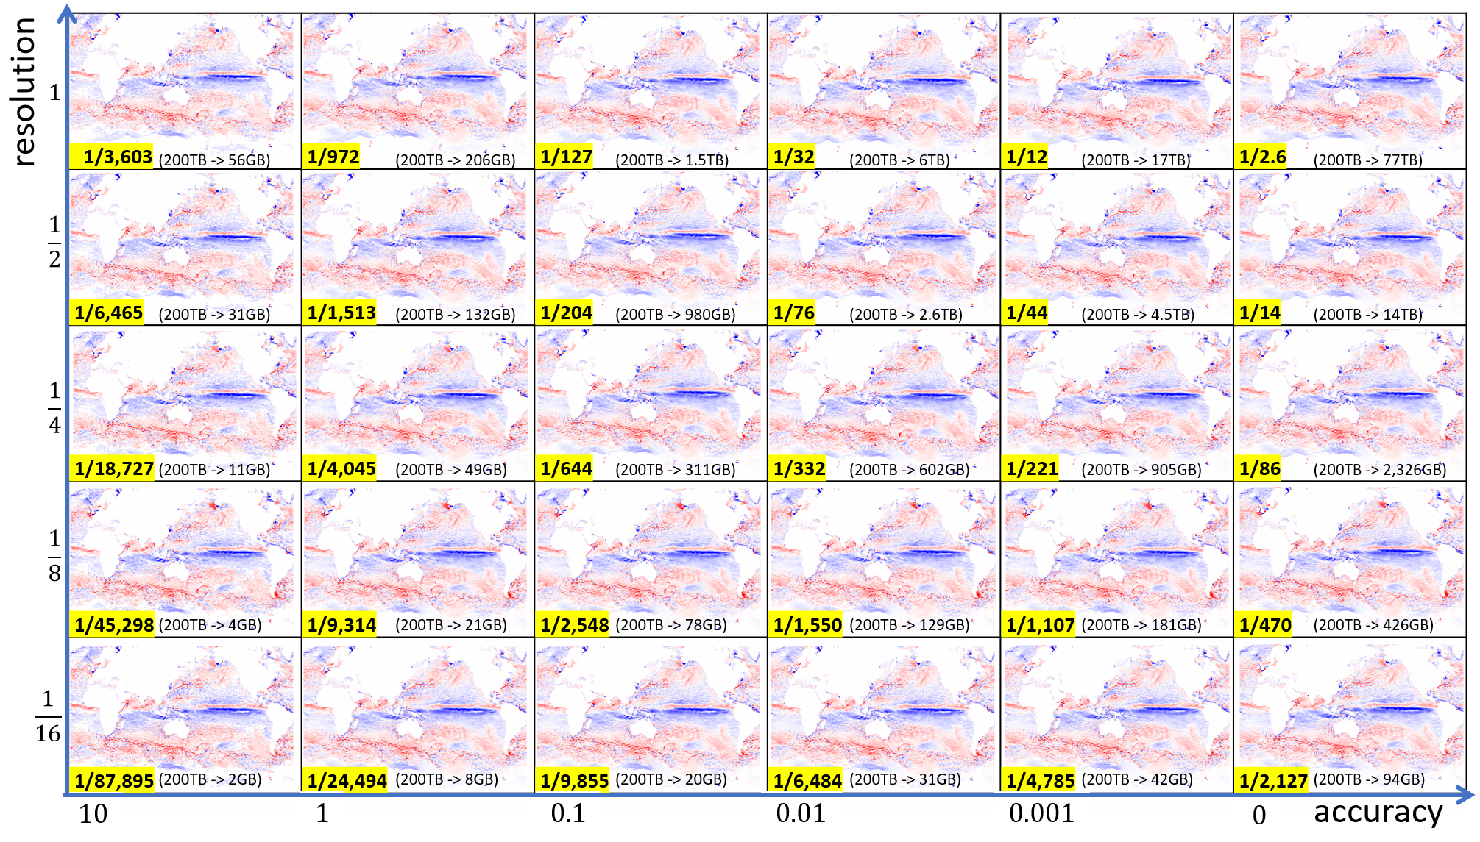

**Figure 5 -** LLC2160 data reconstructed at different resolution and accuracy levels. The numbers in yellow indicate the data reduction ratio from the original data format.

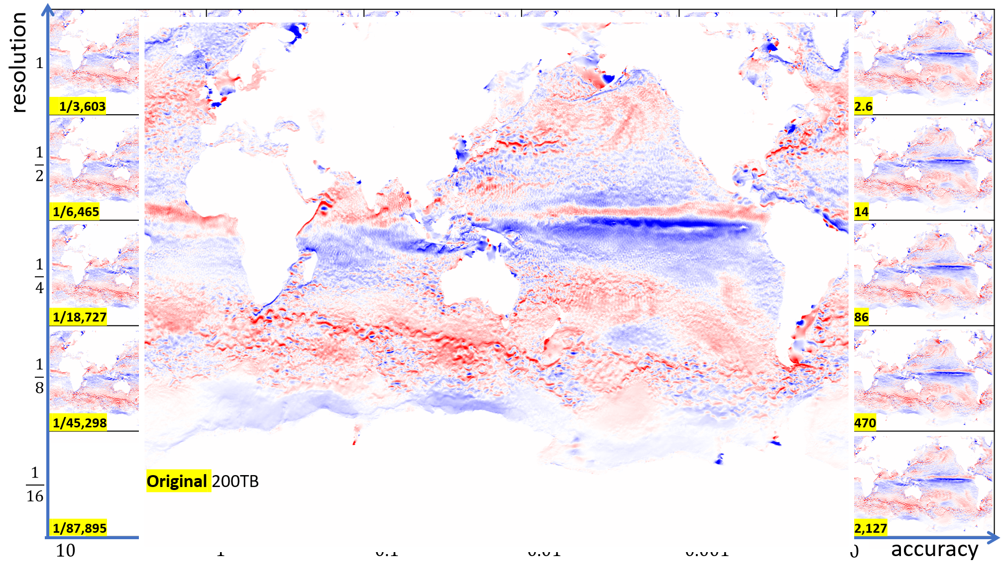

**Figure 6 -** Visualization of the original east-wind velocity field (200 TB).

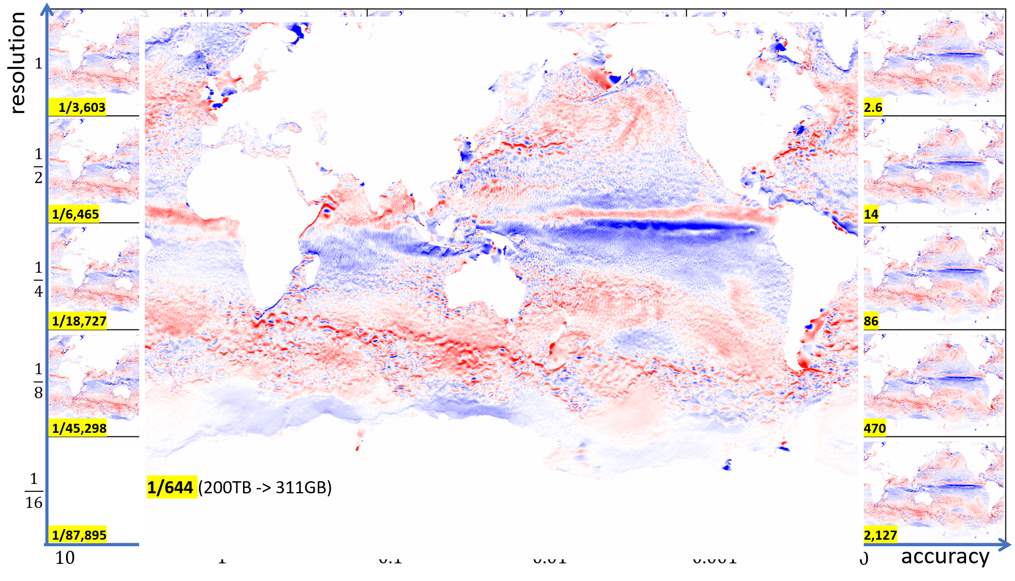

**Figure 7 -** Visualization of the same field as in Figure 6, but reduced by a factor of 600x, which is visually identical to the original field.

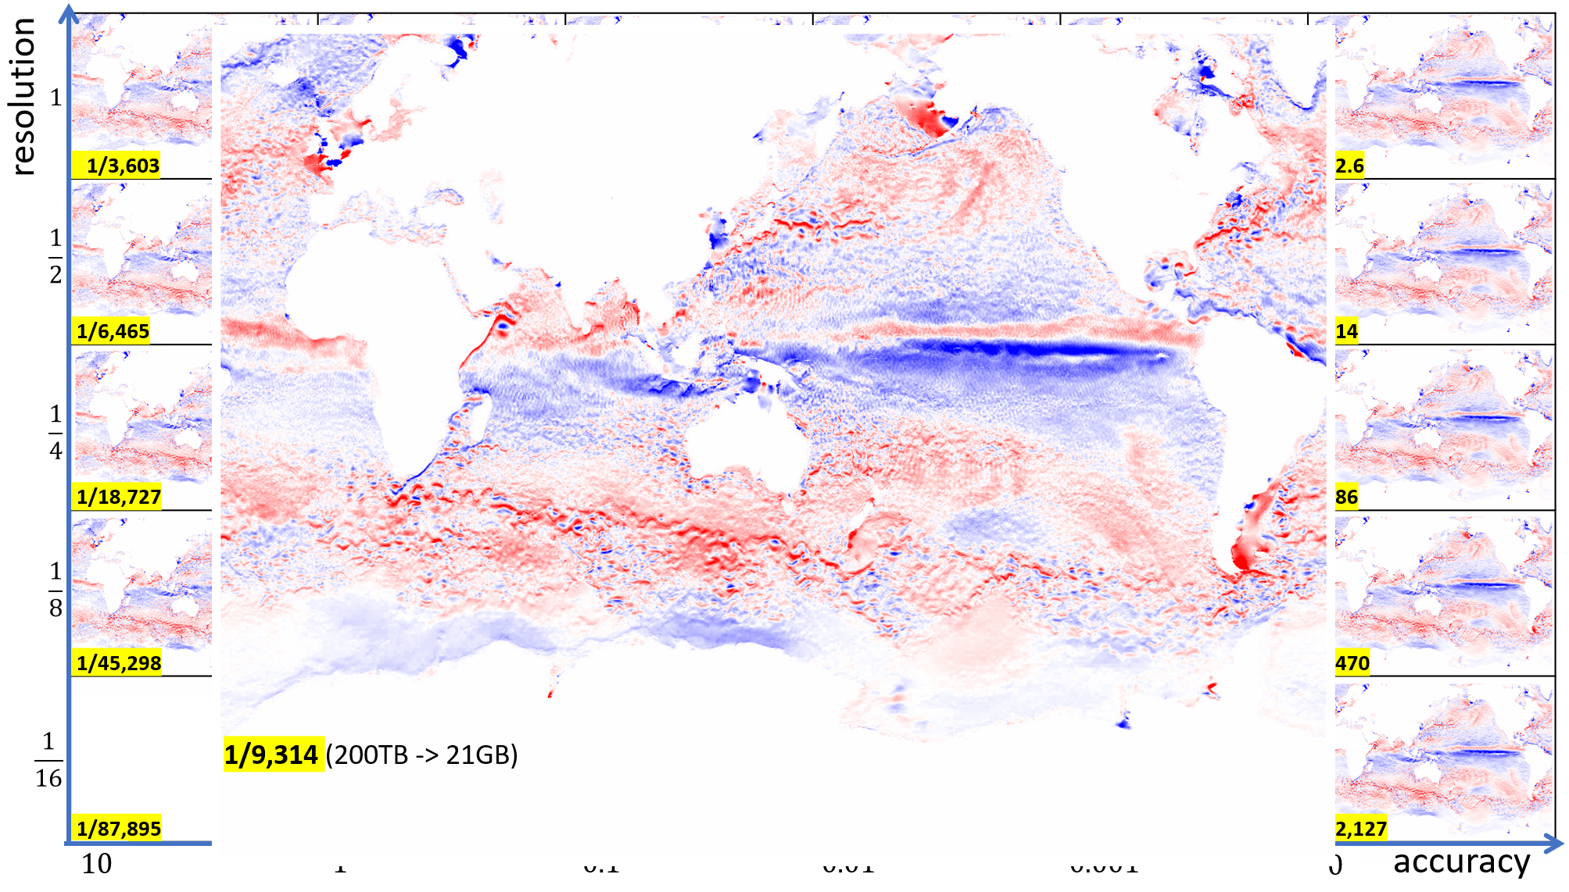

**Figure 8 -** Visualization of the same field as in Figure 6, but reduced by a factor of almost 10000x, with minimal loss in visual quality.

* Converted 64 time-steps of the DYAMOND MITgcm 4320 lat-lon-cap simulation of the ocean to our own format and showed interactive 3D visualization of the data in our own viewer. Domain scientists can create a scene with specific parameters (time step, slice positions, color maps, etc.), save the scene in an XML file, and share the file with other scientists who can open the scene file and see exactly the same view that was saved. See Figure 1.
* Developed interactive visualization of the above atmosphere data in Jupyter notebook with animation, vertical and horizontal slicing at user-specified coordinates, remote streaming, and local caching of data. The notebook has been shared with domain scientists and can be opened by anyone with an internet connection. The data is streamed from a server located at the University of Utah. User interactions are handled as asynchronous events to avoid blocking the interface, ensuring smooth interaction. This interface is based on the Bokeh GUI library and can be deployed as a local Jupyter Notebook to a web dashboard (Figure 9).

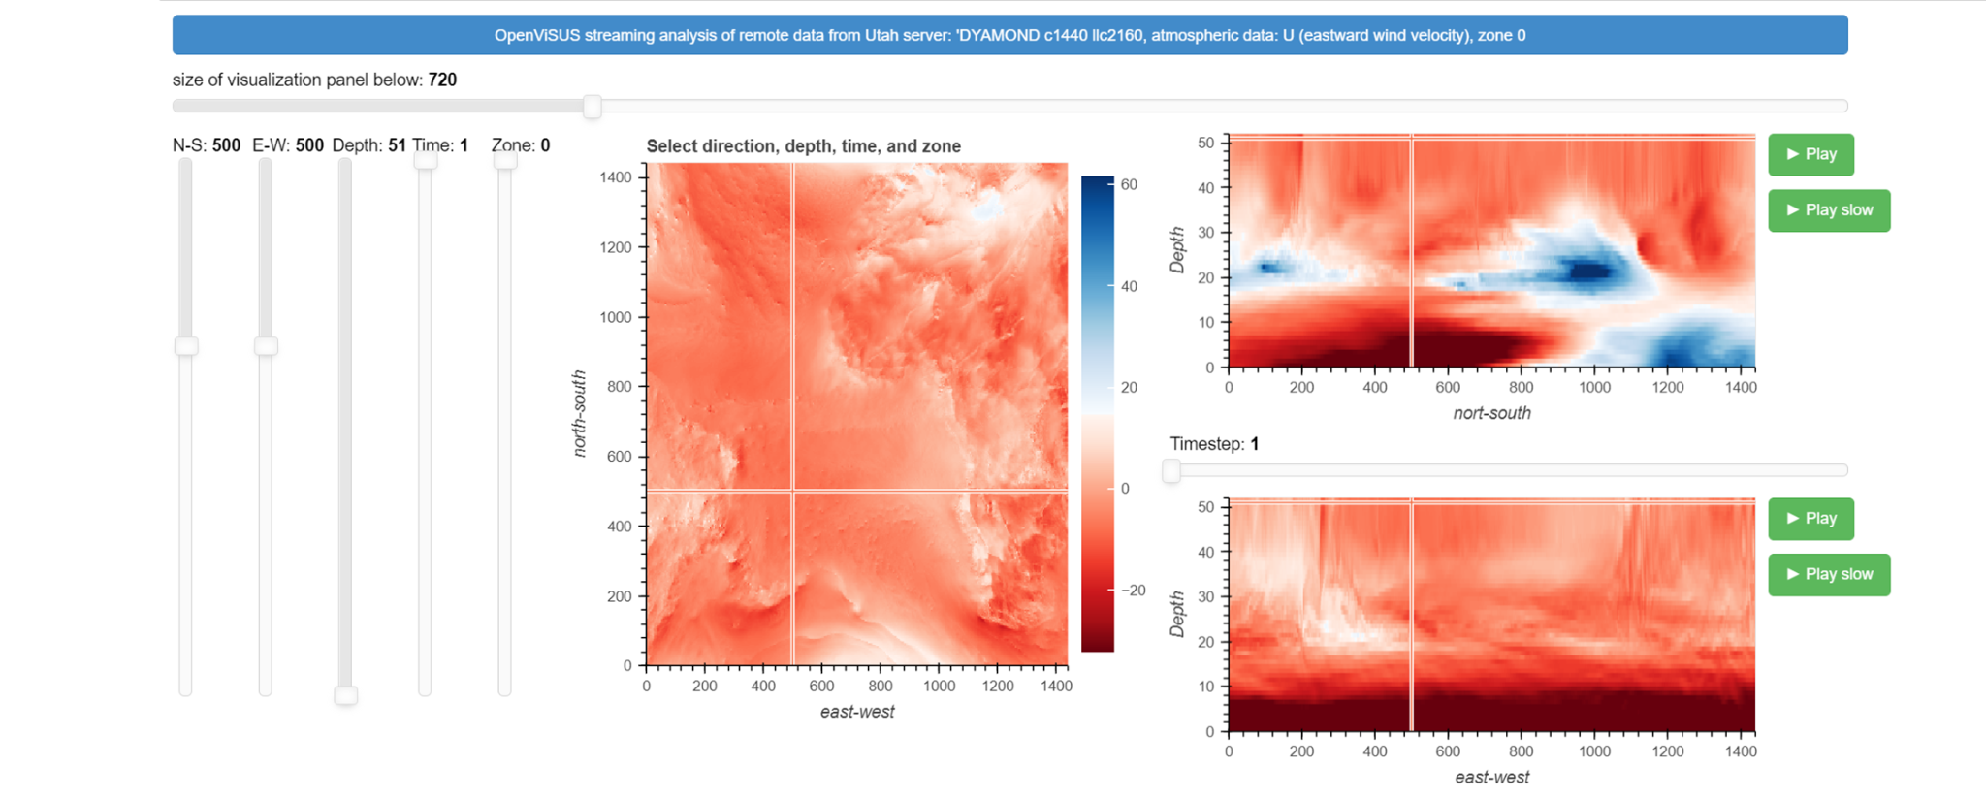

**Figure 9 -** Interactive visualization and animation of the ocean simulation data, east-wind velocity field, 10,000 time steps. All slicing options (horizontal, vertical X, vertical Y) are supported. Data is streamed remotely and cached locally.

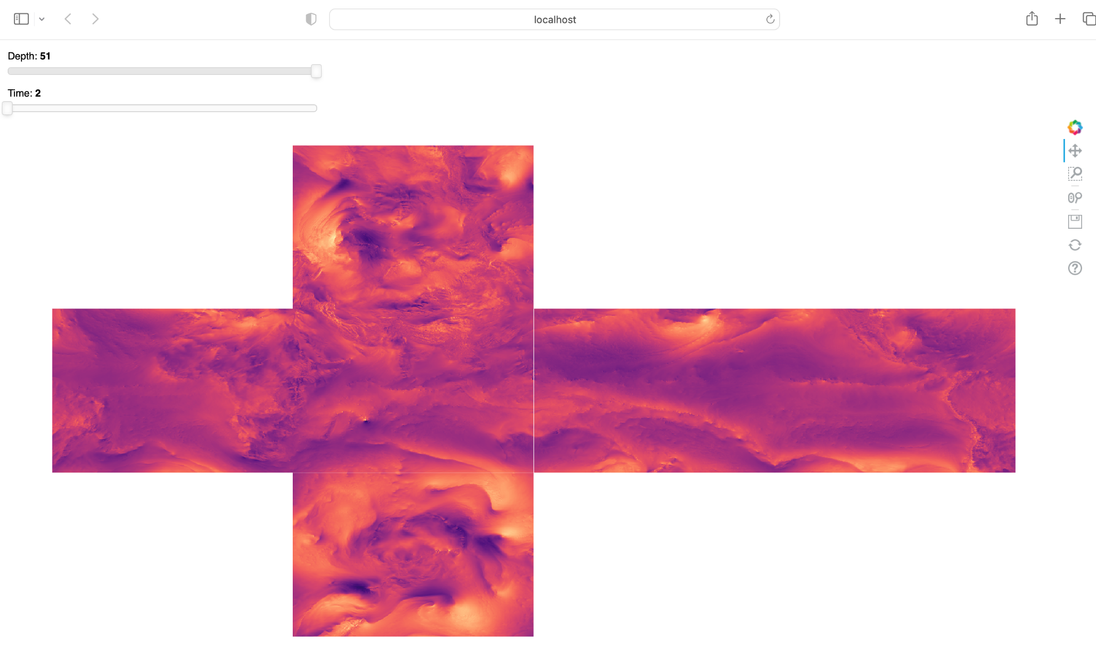

**Figure 10:** Interactive visualization of all six sides of DYAMOND 1440 cube-sphere simulation of the atmosphere data simultaneously using bokeh server. Data is streamed remotely and cached locally.

* Developed a streamlined pipeline to process data conversion from NETCDF format to our encoding smoothly.
  + Converted ~24TB of DYAMOND 1440 cube-sphere simulation of the atmosphere data with 10269 timesteps from NetCDF to our encoding within the NAS server
  + The average conversion speed to our encoding for this dataset is ~500GB/hour, and can be further optimized using fine-tuned concurrency techniques.
* Deployed a bokeh server locally to visualize a stitched version of all six faces of the cube data simultaneously with changing depths and timesteps as needed by the users (Figure 10).